 

WALCHAND COLLEGE OF ENGINEERING, SANGLI

(AN AUTONOMOUS INSTITUTE)

DEPARTMENT OF ELECTRONICS ENGINEERING

ELESA

**EL**ectronics **E**ngineering **S**tudents **A**ssociation

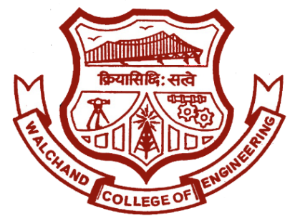

**Walchand College of Engineering, Sangli.**

(An autonomous institute)

ELESA

Electronics Engineering Students’ Association

Email: [walchand.elesa@gmail.com](mailto:walchand.elesa@gmail.com) Website: [www.elesa.co.in](http://www.elesa.co.in)

To,

Dr. B. G. Patil,

Dean Students Welfare,

Walchand College of Engineering,

Sangli.

SUBJECT: Proposal for activities of ELESA in academic year 2018-19.

Respected Sir,

ELESA (Electronics Engineering Students Association) is a technical club of Electronics Department, Walchand College of Engineering, Sangli. ELESA works for development and growth of students especially in Electronics Engineering. This is proposal for the activities to be conducted by ELESA in the academic year 2018-19. All the contents in the proposal is legitimate and true to best of my knowledge. We urge you to grant permission for conducting the events mentioned in this proposal.

Yours sincerely,

Approved By,

Dr. B.G. Patil

Dean Students Welfare,

WCE Sangli.

Dr. G. V. Parishwad,

Director,

WCE Sangli.

Dr. B. G. Patil

H.O.D., Dept. of Electronics

Mr. Mahadev Mishal

President, ELESA

Mr. R. G. Mevekari

Staff Advisor, ELESA

|  |  |
| --- | --- |
| **Name of person** | **Post** |
| Dr. B. G. Patil | H. O. D. Electronics |
| Mr. R. G.Mevekari | Staff Adviser ELESA |
| Mahadev Mishal  (9420886521) | President |
| Atul Zine  (9823147633) | Vice President |
| Shrihari Waskar  (8275458491) | External Affairs Officer/ Secretary |
| Pritesh Pawar | Event Director |
| Vrushali Shelke |
| Nikita Nikhare |
| Sachin Jadhav | Technical Director |
| Kajal Munde |
| Sneha Shete | Club Service Director |
| Tanuja Chopade | Aptitude Developer |
| Priya Bhosle |
| Pallavi Nipanikar | Content Developer |
| Sayali Dabhade |
| Anand Narwade | Editor |
| Iftasham Attar |
| Sandesh Manwar | Treasurer |
| Vikram Sapate | Web Developer |
| Pritesh Pawar |

ELESA 2018-19

About ELESA

Electronics Engineering Students Association is a departmental; technical club of Walchand College of Engineering, Sangli. Which was established in the year 1992 has a trademark feature of reinventing itself every time, year after year. The ELESA represents current students within the Electronics Engineering Dept. at WCE, Sangli. Our goal is to organize social and professional activities which strengthen and enrich the community within the department, and to help publicize various research activities within the department. We organize social events and help to communicate with the department and the students. Here, the students organize themselves to develop and improve various skills and to impart technical knowledge and keep in pace with the latest trends in technology by arranging club services.

EVENTS

1. **ELESA AWARDS:** ELESA felicitate the students who perform extra-ordinary in the academic year for ELESA with various awards.
2. **Summer Special Events:** ELESA organises “Summer Special Awards” in the month of June for students in Electronics Engineering. The activity consists of technical as well as non-technical events.
3. **Departmental Visit:** Every year ELESA organise Departmental visit for newly admitted students in Electronics Engineering. This activity helps them know about the Department of Electronics.
4. **General Interest Meet:** GIM is conducted by ELESA every year for First Year students. This activity helps them make familiar with ELESA family. They also learn some of the recent technologies which are not included in academics.
5. **Scavenger Hunt:** ELESA organises Scavenger Hunt or Treasure Hunt for newly admitted First Year Electronics engineering students in order to increase bonding with seniors.
6. **e-Yantra practice Test:** ELESA organises e-Yantra practice test for all electronics students so that they can perform well in National Level Robotics Competition.
7. **Teachers Day Celebration**: ELESA celebrates Teachers day on 5th Sept to felicitate and show respect to the work of all faculties in the Department.
8. **ELECTROVERT**: ELESA every year organise a state level mega event. This event is completely organised by the board members of ELESA. This event helps ELESA get a global identity. This 2-day event consist of technical events, management events, quizzes, etc. This event has very good response every year.
9. **Industrial Visit:** This year ELESA is planning to arrange an IV to nearby industries to get industrial exposure.
10. **Alumni Meet:** ELESA organise an interactive session with the Alumni. Alumni share their experience with the students and also guide them for their carrier.
11. **Workshops:** ELESA conducts various workshops like Proteus workshop for First Year students, HTML, PHP, CSS workshops.
12. **Intra Club Activity:** We arrange intra club activity for overall development of students. Intra Club Activity helps students acquire some special skillsets which include technical, management and soft skills along with team work.
13. **Excellence (Mock Campus Event):** Every Year ELESA organise a Mock Campus Event for board members to make them understand the recruitment process.
14. **Weekly Club Services:** Weekly Club Services include technical sessions, aptitude sessions, group building activities, etc. Club Service results in overall development of each individual.
15. **Social Activities:** We also organise various social activities to contribute to the society we live in.

ELECTROVERT 2017

Event Expenditure

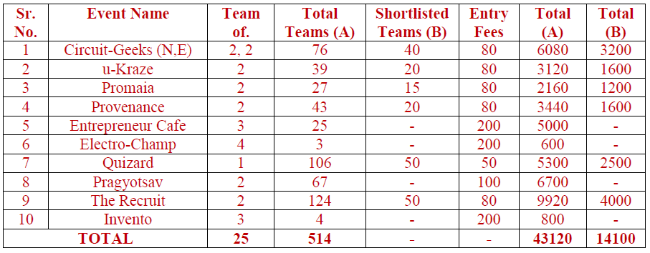Participation Fees:

* Total Amount Collected Through Entries = 43120+14100 = 57220
* Sponsorship = 9000
* Lead College Scheme=37,122
* Total Amount Collected = 57220+9000+37122= 103,342

Trophies:

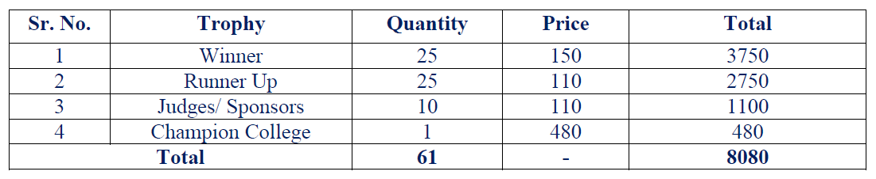

Stationary:

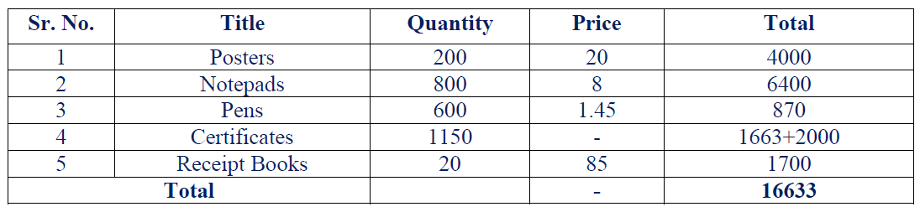

* Cash Prize:

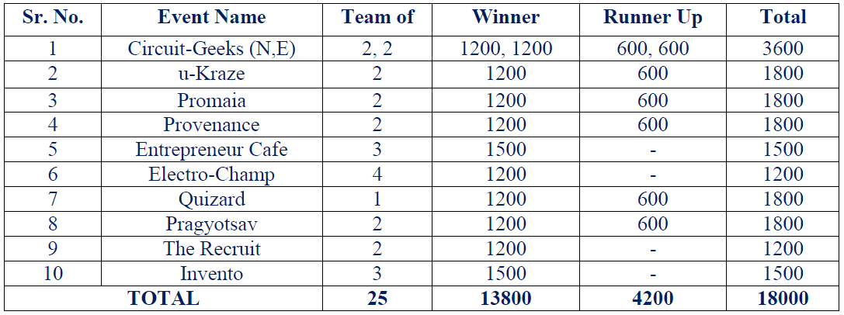

* Refreshment = 9000
* Diary for Board Members = 2450
* Decoration = 4078
* Components = 682
* Inauguration = 510
* Reimbursement = 4492
* Paper Prints = 100
* Banner = 1440
* Total Amount Spent = 8080+16633+18000+9000+2450+4078+682+510+4492+100+1440=65465

Net Profit: 103,342-65,465=37,877

|  |  |  |
| --- | --- | --- |
| **EVENT** | **DATE** | **Tentative Budget** |
| **ELESA AWARDS** | Annual Event | ₹ 2,000 |
| **Summer Special Events** | 1st June – 15th July 2018 | ₹ 295 |
| **Departmental Visit** | 3nd August 2018 | ₹ 250 |
| **General Interest Meet** | 6th August 2018 | ₹ 400 |
| **Teachers’ Day Celebration** | 5th Sept 2018 | ₹ 2,500 |
| **ELECTROVERT 2k17** | 8th and 9th Sept 2018 | ₹ 68750 |
| **Alumni Meet** | Weekend of Jan 2019 | ₹ 1,500 |
| **Industrial Visit** | Oct. 2018 or Feb 2019 | ₹ 1,500 |
| **Workshops** | Weekends | N.A. |
| **Intra Club** | Dec 2018 to Jan 2019 | ₹ 4,000 |
| **Excellence** | March 2019 | ₹ 2,500 |
| **Weekly Club Services** | Every Monday | ₹ 150 each |
| **Social Activities** | As required | ₹  500 |



**Walchand College of Engineering, Sangli.**

(An autonomous institute)

ELESA

Electronics Engineering Students’ Association

Email: [walchand.elesa@gmail.com](mailto:walchand.elesa@gmail.com) Website: [www.elesa.co.in](http://www.elesa.co.in)

To,

Mr. R. G. Mevekari

Staff adviser, ELESA

Subject: Regarding annual financial report 2017-18.

Respected Sir,

In the academic year 2017-18, ELESA successfully organized various events. The total expenditure of every event is given in following table.

|  |  |
| --- | --- |
| **Previous year balance** | **84282** |

|  |  |  |  |  |
| --- | --- | --- | --- | --- |
| Sr. No | Events | Earned | Expenditure | Difference |
| 1 | Summer Special | - | 400 | -400 |
| 2 | GIM | - | 360 | -360 |
| 3 | Teachers Day | - | 470 | -470 |
| 4 | Electrovert 2017 | 103,342 | 65,465 | 37,877 |
| 5 | Roboholics | 6500 | 2267 | 4233 |
| 6 | Proteus Workshop | 7000 | 5418 | 1582 |
| 7 | Excellence | 1950 | 800 | 1250 |
| 8 | ELESA Awards | - | 5400 | -5400 |
| 9 | Web Hosting | - | 1190 | -1190 |
| 10 | Interest from bank | 3808 | - | 3808 |
| **Profit** | | | | **40,930** |
| **Current balance** | | | | **1,25,212** |

I, kindly request you to consider this report for the chronicles carried out in the academic year 2016-17.

Mr. Shubham Mhatre

President, ELESA